Crypt-Arithmetic Problem
AIM:
To write a Python program to solve a Crypt-Arithmetic Problem by assigning unique digits to letters.
ALGORITHMS:
1. Start.
2. Read the given arithmetic puzzle.
3. Assign unique digits to the letters.
4. Ensure that leading letters are not assigned zero.
5. Check whether the arithmetic equation is correct.
6. Display the valid solution.
7. Stop.

CODE:
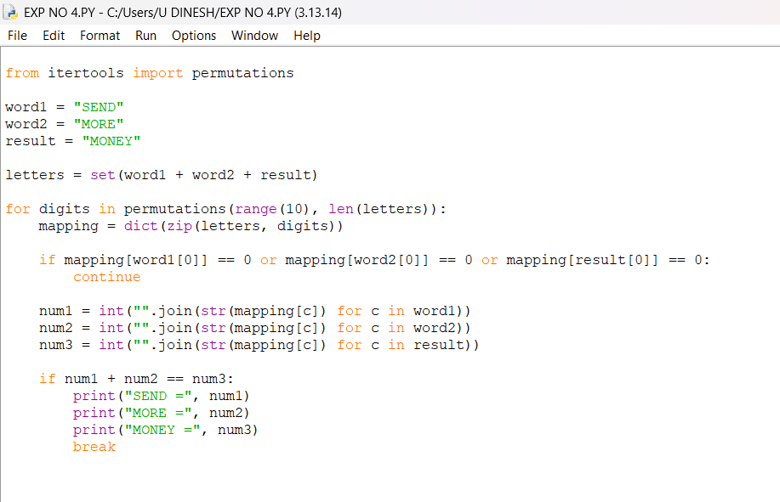
OUTPUT:
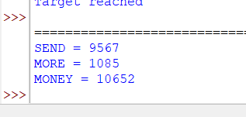

RESULT:
Crypt-Arithmetic Problem: The digits are assigned to letters to satisfy the arithmetic equation

